CO-OPERATIVE AUDIT AND SUPERVISION CORPORATION
(COASCO)
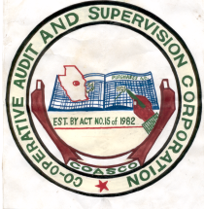

Cooperative Audit and Supervision Corporation (COASCO) was established by Act of Parliament No. 15 of 1982 and revised on April 2005. COASCO Mission is to conduct it activities in openness and transparency pertaining to client Auditing and Supervision, Research and Consultancy in all co-operative and non-operative entities, while its Vision is to become a professional Audit firm and to be the leader among audit firm, currently the corporation operate in 14 regions country wide.

We are pleased to inform you that the recognized email official of COASCO is info@coasco.go.tz
Therefore other email such yahoo, Gmail and etc from is not official applicable
We make these changes because of security and official sensitive information can be stolen with attacker
Also we will create email account to all COASCO staff member with temporally password and you will change your provided password quickly for security
Therefore your sensitive detail information will be sent to your Religion officer for further information

